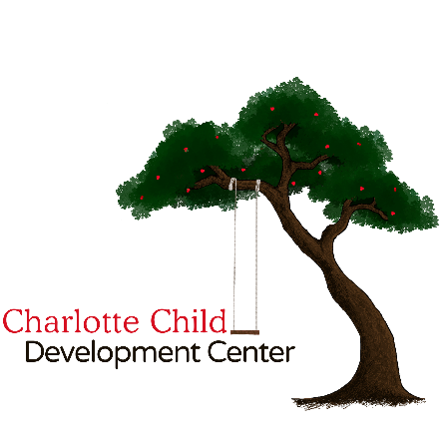
Wait List Application
Tour Date _____________
PARENT/GUARDIAN INFORMATION
Mother’s Last Name: |  |  |  | Mother’s First Name:
Father’s Last Name: |  |  |  | Father’s First Name:
Mother’s Cell Phone: |  |  |  | Father’s Cell Phone:
Mother’s Email: |  |  |  | Father’s Email:
CHILD INFORMATION
Last Name: |  | First Name: |  |  |  |  | M.I.: | DOB or Due Date
Street Address:
City: |  |  |  |  | State: |  |  | Zip:
Home or Cell Phone: |  |  | Desired Start Date: |  |  |  |  |  | Gender:
St Luke’s Member? YES NO | Sibling enrolled? YES NO |  |  |  |  | If so, name & age?
CHARLOTTE CHILD DEVELOPMENT CENTER POLICY INFORMATION & SIGNATURE
There will be a NON-REFUNDABLE Wait List Fee of $75.00. Upon acceptance of a child’s enrolment in the program, tuition is due within one (1) week of acceptance. Otherwise, no spot will be held, and the admission process will continue for the next child on our Wait List. Should a spot become available, you will have to pay monthly tuition in order to save this spot for your child. This policy will hold true for any age child who is on the Wait List. You may decline a space ONE (1) me and retain your spot on the Wait List. If you decline a second me, you will be moved to the bottom of the list.
Please return completed form & Wait List Fee to:
Charlotte Child Development Center
3200 Park Rd
Charlo e, NC 28209
Or email to Cynthia.Kara@gmail.com
Signature |  |  |  |  |  |  |  | Date
FOR OFFICE USE ONLY

